522H0068 – Pham Van Phuc

ARRAY

Cau1

import java.util.Scanner;

public class Lab5 {

public static *int* maxEven(*int*[] *a*) {

*int* max = -1, i;

for (i = 0; i <*a*.length; i++) {

if (*a*[i] % 2 == 0){

max = *a*[i];

break;

}

}

for (i = 0; i < *a*.length; i++) {

if ((*a*[i] % 2 == 0) && (*a*[i] > max)) {

max = *a*[i];

}

}

return max;

}

public static *int* minOdd(*int*[] *a*) {

*int* min = 0;

for (*int* i = 0; i <*a*.length; i++) {

if (*a*[i] % 2 == 1){

min = *a*[i];

break;

}

}

for (*int* i = 0; i < *a*.length; i++) {

if ((*a*[i] % 2 == 1) && (*a*[i] < min)) {

min = *a*[i];

}

}

return min;

}

public static *int* sumEven(*int*[] *a*) {

*int* s = 0;

for (*int* i = 0; i < *a*.length; i++) {

if (*a*[i] % 2 == 0) {

s += *a*[i];

}

}

return s;

}

public static *int* prodOdd(*int*[] *a*) {

*int* s = 1;

for (*int* i = 0; i < *a*.length; i++) {

if (*a*[i] % 2 == 1) {

s *= *a*[i];

}

}

return s;

}

public static *int* idxFirstEven(*int*[] *a*) {

*int* idx = -1;

for (*int* i = 0; i < *a*.length; i++) {

if (*a*[i] % 2 == 0 ) {

idx = i;

break;

}

}

return idx;

}

public static *int* idxLastOdd(*int*[] *a*) {

*int* idx = -1;

for (*int* i = 0; i < *a*.length; i++) {

if (*a*[i] % 2 == 1 ) {

idx = i;

}

}

return idx;

}

//function input

public static *int*[] input(*int* *n*) {

*int*[] arr = **new** *int*[*n*];

Scanner input = **new** Scanner(System.in);

for (*int* i = 0; i < *n*; i++) {

arr[i] = input.nextInt();

}

return arr;

}

public static *int* sumMEMO(*int*[] *a*) {

*int* s = 0;

if (maxEven(*a*) == -1) {

}

else {

s = s + maxEven(*a*);

}

if (minOdd(*a*)== 0) {

}

else {

s = s + minOdd(*a*);

}

return s;

}

public static *void* main(String[] *args*) {

Scanner sc = **new** Scanner(System.in);

System.out.println("Moi nhap so phan tu cua mang");

*int* n = sc.nextInt();

System.out.println("Moi nhap cac phan tu cua mang");

*int*[] arr = **new** *int*[n];

arr = input(n);

if (maxEven(arr) == -1 ) {

System.out.println("Not exist even number in array");

}

else {

System.out.println("greatest even number in an array is : " + maxEven(arr));

}

if (minOdd(arr) == 0 ) {

System.out.println("Not exist odd number in array");

}

else {

System.out.println("smallest odd number in an array is : " + minOdd(arr));

}

System.out.println("sum of the greatest even number and the smallest odd number in an array is : " + sumMEMO(arr));

System.out.println("sum of even numbers in an array = " + sumEven(arr));

System.out.println("product of odd numbers in an array = " + prodOdd(arr));

if (idxFirstEven(arr) == -1 ) {

System.out.println("Not exist even number in array");

}

else {

System.out.println("position of the first even number in the array is : " + idxFirstEven(arr));

}

if (idxLastOdd(arr) == -1 ) {

System.out.println("Not exist odd number in array");

}

else {

System.out.println("position of the last odd number in the array is : " + idxLastOdd(arr));

}

sc.close();

}

}

Man hinh chay

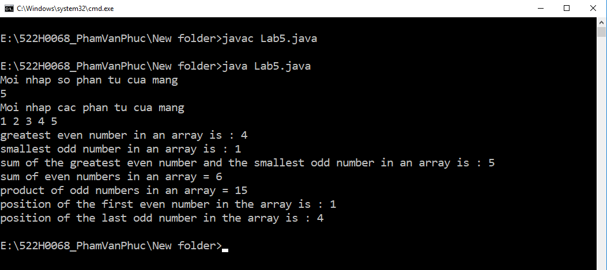

STRING

Cau 1

Code

import java.util.Scanner;

public class Lab5 {

public static *int* countName(String *name*) {

*int* dem = 0;

*char*[] c = *name*.toCharArray();

for (*int* i = 0; i < c.length; i++) {

if (c[i] == ' ') {

dem += 1;

}

}

return dem;

}

public static String shortName(String *str*) {

String[] stringarr = *str*.split(" ");

String s = stringarr[countName(*str*)].concat(" " + stringarr[0]);

return s;

}

public static String hashtagName (String *str*) {

String[] stringarr = *str*.split(" ");

String s = "#" + stringarr[countName(*str*)];

s = s.concat(stringarr[0]);

return s;

}

public static String upperCaseAllVowel(String *str*) {

*str* = *str*.replace('u','U');

*str* = *str*.replace('e','E');

*str* = *str*.replace('o','O');

*str* = *str*.replace('a','A');

*str* = *str*.replace('i','I');

return *str*;

}

public static String upperCaseAllN(String *str*) {

return *str*.replace('n','N');

}

public static *void* main (String *args*[]) {

Scanner sc = **new** Scanner(System.in);

System.out.println("522H0068- Pham Van Phuc");

System.out.println("Moi nhap ten day du");

String name = sc.nextLine();

System.out.println("Short Name : " + shortName(name));

System.out.println("Hashtag Name : " + hashtagName(name));

System.out.println("Upper All Vowel : " + upperCaseAllVowel(name));

System.out.println("Upper n Letter : " + upperCaseAllN(name));

sc.close();

}

}

Man hinh chay:

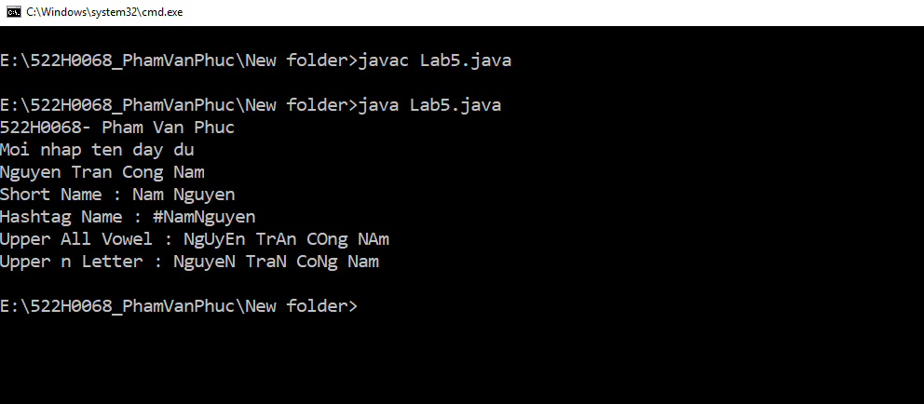

Cau 2

Code

import java.util.Scanner;

public class Lab5 {

public static *int* countWord(String *paragraph*) {

*int* dem = 0;

*char*[] c = *paragraph*.toCharArray();

for (*int* i = 0; i < c.length; i++) {

if (c[i] == ' ') {

dem += 1;

}

}

return dem;

}

public static *int* countSentences(String *paragraph*) {

*int* dem = 0;

*char*[] c = *paragraph*.toCharArray();

for (*int* i = 0; i < c.length; i++) {

if (c[i] == '.') {

dem += 1;

}

}

return dem;

}

public static *void* main(String *args*[]) {

Scanner sc = **new** Scanner(System.in);

System.out.println("522H0068 - Pham Van Phuc");

String para = ("The Edge Surf is of course also a whole lot better, which will hopefully win Microsoft some converts. It offers time trial, support for other input methods like touch and gamepads, accessibility improvements, high scores, and remastered visuals.");

System.out.println("Number words in paragraph : " + countWord(para));

System.out.println("Number sentences in paragraph : " + countSentences(para));

sc.close();

}

}

Man hinh chay

OOP

Cau 1 - Club

Code :

public class Club {

private String name;

private *int* wins;

private *int* draws;

private *int* losses;

//constructors

public Club() {

*this*.name = "";

*this*.wins = 0;

*this*.draws = 0;

*this*.losses = 0;

}

public Club(String *name*, *int* *wins*, *int* *draws*, *int* *losses*) {

*this*.name = *name*;

*this*.wins = *wins*;

*this*.draws = *draws*;

*this*.losses = *losses*;

}

public Club(Club *club*) {

*this*.name = *club*.name;

*this*.wins = *club*.wins;

*this*.draws = *club*.draws;

*this*.losses = *club*.losses;

}

//method

public String getName() {

return *this*.name;

}

public *int* getWins() {

return *this*.wins;

}

public *int* getDraws() {

return *this*.draws;

}

public *int* getLosses() {

return *this*.losses;

}

public *void* setName (String *name*) {

*this*.name = *name*;

}

public *void* setWins(*int* *wins*) {

*this*.wins = *wins*;

}

public *void* setDraws(*int* *draws*) {

*this*.draws = *draws*;

}

public *void* setLosses(*int* *losses*) {

*this*.losses = *losses*;

}

public *int* numMatchesPlayed() {

return *this*.wins + *this*.draws + *this*.losses;

}

public *boolean* isFinish() {

if (numMatchesPlayed() >= 10)

return true;

return false;

}

public *int* getPoints() {

return 3\**this*.wins + 1\**this*.draws;

}

public String toString() {

return "Club " +name + " : " + wins + " / " + draws + "/ " + losses;

}

}

Code ham test

public class testClub {

public static *void* main (String *args*[]) {

System.out.println("522H0068 - PhamVanPhuc");

Club cl1 = **new** Club();

cl1.setName("PPFC1");

cl1.setWins(5);

cl1.setDraws(3);

cl1.setLosses(2);

System.out.println("Name of Club is : " + cl1.getName());

System.out.println("Wins of Club is : " + cl1.getWins());

System.out.println("Draws of Club is : " + cl1.getDraws());

System.out.println("Losses of Club is : " + cl1.getLosses());

System.out.println("Matched Played of Club is : " + cl1.numMatchesPlayed());

if (cl1.isFinish() == true) {

System.out.println("the league finished");

}

else {

System.out.println("the league hasn't finished");

}

System.out.println("Points is " + cl1.getPoints());

System.out.println(cl1);

}

}

MMan hinh chay

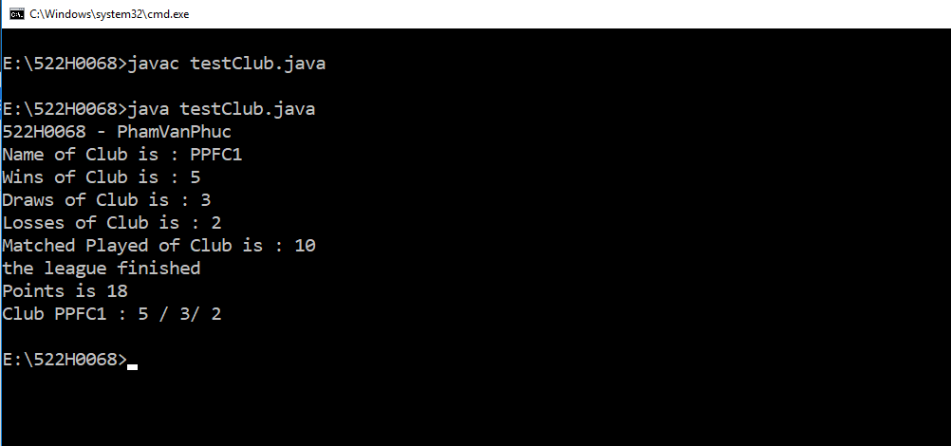

Cau2 - RegularPolygon

Code

public class RegularPolygon {

private String name;

private *int* edgeAmount;

private *double* edgeLength;

public RegularPolygon() {

*this*.name = "";

*this*.edgeAmount = 3;

*this*.edgeLength = 1;

}

public RegularPolygon(String *name*, *int* *edgeAmount*, *double* *edgeLength*) {

*this*.name = *name*;

*this*.edgeAmount = *edgeAmount*;

*this*.edgeLength = *edgeLength*;

}

public RegularPolygon(String *name*, *int* *edgeAmount*) {

*this*.name = *name*;

*this*.edgeAmount = *edgeAmount*;

*this*.edgeLength = 1;

}

public RegularPolygon(RegularPolygon *polygon*) {

*this*.name = *polygon*.name;

*this*.edgeAmount = *polygon*.edgeAmount;

*this*.edgeLength = *polygon*.edgeLength;

}

//methods

public String getName() {

return *this*.name;

}

public *int* getEdgeAmount() {

return *this*.edgeAmount;

}

public *int* getEdgeLength() {

return *this*.getEdgeLength();

}

public *void* setName(String *name*) {

*this*.name = *name*;

}

public *void* setEdgeAmount(*int* *num*) {

*this*.edgeAmount = *num*;

}

public *void* setEdgeLength (*double* *length*) {

*this*.edgeLength = *length*;

}

public String getPolygon() {

if (*this*.edgeAmount == 3)

return "Triangle";

else if (*this*.edgeAmount == 4)

return "Quadrangle";

else if (*this*.edgeAmount == 5)

return "Pentagon";

else if (*this*.edgeAmount == 6)

return "Hexagon";

else

return "Polygon has the number of edges greater than 6";

}

public *double* getPerimeter() {

return edgeLength*edgeAmount;

}

public *double* getArea() {

switch (*this*.edgeAmount) {

case 3:

return *this*.edgeAmount\**this*.edgeAmount*0.433;

case 4:

return *this*.edgeAmount\**this*.edgeAmount*1;

case 5:

return *this*.edgeAmount\**this*.edgeAmount*1.72;

case 6:

return *this*.edgeAmount\**this*.edgeAmount*2.595;

default :

return -1;

}

}

public String toString() {

return *this*.name + " - " + getPolygon() + " - " + getArea();

}

}

Code test

public class testRegularPolygon {

public static *void* main (String *args*[]) {

System.out.println("522H0068 - Pham Van Phuc");

RegularPolygon h1 = **new** RegularPolygon();

h1.setName("hinh 1");

h1.setEdgeAmount(5);

h1.setEdgeLength(3);

System.out.println("It is " + h1.getPolygon());

System.out.println("perimeter = " + h1.getPerimeter());

System.out.println("area = " + h1.getArea());

System.out.println(h1);

}

}

Man hinh chay

